

  

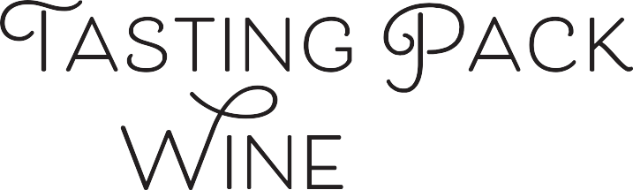

**101**

# TASTING NOTES BY: MASTER SOMMELIER MAX KAST

Medium-plus intensity of aromas with notes of fresh lemon, lime, orange pith, under-ripe green apple and pear, secondary notes of bay leaf, jasmine, beeswax, creme fraiche, and peanut shell (the latter two evidence of lees aging), a wet stone mineral note. On the palate the wine is bone dry with a creamy texture, fruit dominant and a long finish.

# TASTING NOTES BY: ADVANCED SOMMELIER BRANDON FORD

The wine is almost colorless. It’s semi-aromatic with notes of just ripe lemon and underripe orchard fruits of green apple and pear. On the palate there is white peach and savory herbs and a hay note. There is a crème fraiche note that leads me to believe there was lees aging and or stirring. There is also crushed stones and it’s slightly reductive to me with no new oak.

## Sweetness:

## Tannin:

## Alcohol:

## Acid:

## Oak:

Bone dry

Medium Minus

High

old world   
or new?

climate?

grape?

country?

place



# A bottle of wine Description automatically generatedWINE DETAILS:

## Winery:

## Cuvee:

## Grape:

## Country:

## Regions:

## Vintage:

**Alcohol:**

**Elevage:**

**Winemaking:**

Tyrell’s

Semillon

Australia

Hunter Valley

2018

11.5%

Fermented and aged in stainless steel –

The wine also spent some time on lees

Tyrell’s is a 5th generation family winery

That was established in 1858. Tyrell’s

Winery has gained considerable

accolades for their “Vat 1” Semillon

# NOTES :

Hunter Valley Semillon is a very difficult wine to blind taste. It is a high acid, lower alcohol, lighter-bodied new world wine. It is sometimes confused with Muscadet, but the lees aromas of Muscadet are much more prevalent, and the alcohol is higher and acid somewhat lower in Muscadet. It is also sometimes confused with Clare Valley or Eden Valley Riesling, it does not have the intensity of aromatics and does not show any petrol or terpinic notes. It is also sometimes confused with Sauvignon Blanc from NZ or France, which will be fuller-bodied, higher in alcohol, high intensity of aroma, and will show obvious Pyrazine. Semillon can show pyrazine, but depends on the vintage. The ultimate key is that Semillon from Hunter is still a fruit-driven wine, the clue that brings you to the new world.

Retail Price: $22

[**Click Here to Reorder**](mailto:colin@flxhospitality.com?subject=Tasting%20Pack%20Reorder) **at F.L.X. Provisions**

In a world of uncertainty, we are:

In Our Element