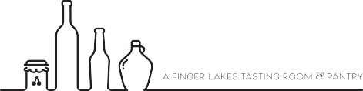

  

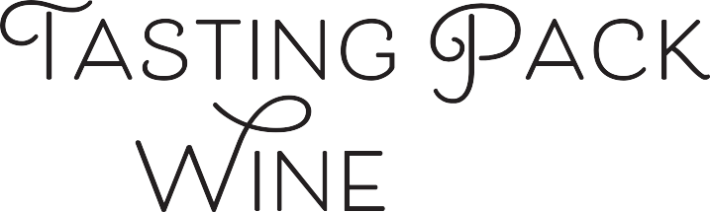

**#1286**

# TASTING NOTES BY: MASTER SOMMELIER DAVID KECK

Yellow with flecks of gold in the rim. Thick, slow-falling tears. The fruit is all ripe and a touch baked, with ripe citrus, lemon curd, underripe pineapple, and Cortland apple. Yellow flowers and slight, underlying stony minerality. Oak is a strong presence in the wine, with vanilla, cardamom, and clove.

# TASTING NOTES BY: F.L.X. TABLE’S MICHALIS KALAMPOUKAS

Pale yellow color with green hue, with medium color concentration and medium plus tears. On the nose it is just ripe, with notes of Meyer lemon, yellow apple and ripe peach. There's also a floral quality of honeysuckle, with notes of mushroom, hazelnut, sourdough and popcorn buttery quality, indication of lees contact and malolactic fermentation. There's detectable oak aging as well, with notes of toast, caramel and baking spice. The wine is dry, textured and round, full bodied with high alcohol and medium plus acidity.

## Sweetness:

## Tannin:

## Alcohol:

## Acid:

## Oak:

Dry

High

Medium PLUS

Present

old world   
or new?

climate?

grape?

country?

place



# A bottle of wine and a glass of beer on a table Description automatically generatedWINE DETAILS:

## Winery:

## Cuvee:

## Grape:

## Country:

## Regions:

## Vintage:

**Alcohol:**

**Elevage:**

**Other:**

Mount Eden Vineyards

Edna Valley

Chardonnay

U.S.A.

Santa Cruz Mountains – California

2017

14%

Barrel fermented in a mix of 2 and 3 year

Old French Burgundy barrles. The wine

undergoes malolactic fermentation

A historic wine estate that was founded

In 1945 & is considered an iconic winery

# NOTES :

Oak narrows the world dramatically, here the fruit dominates and the profile is neutral with regard to the grape variety. Thus it is Chardonnay from somewhere, and the ripeness and dominance of the oak lead us to a classic, if slightly old-school California style. Mount Eden is up high in the Santa Cruz Mountains and makes a sometimes deceptive style of CA Chardonnay in that it can be a bit more reserved than its riper, Napa Valley cousins.

Retail Price: $33

**Order at FLXProvisions.com**

In a world of uncertainty, we are:

In Our Element