

  

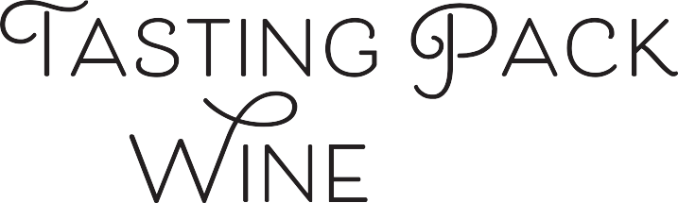

**#170**

# TASTING NOTES BY: MASTER SOMMELIER CHRISTOPHER BATES

Lightly golden yellow color, with hints of green. Aromas of bruised yellow apple, pear and quince, almost cider like. Slightly green vegetal note, like arugula or radish leaf, yellow flowers like dandelions, and white rock. No oak. Both ripe and tart on the palate, with a round filling texture. The bruised fruit and structure are the keys to this wine. Many wines can have similar texture, but, often the lushness is from alcohol, which is not the case in this wine. While the green note makes it easy to jump to Grüner, the slight presence of RS should bring us back.

# TASTING NOTES BY: F.L.X. TABLE’S MICHALIS KALAMPOUKAS

Light yellow with a golden hue, medium color concentration with no staining and tears forming slowly. On the palate is expressive, with red apple, lemon pith, banana peel and quince notes. There's a floral quality, dried honey, ginger and saffron, indicating botrytis, with white truffle, crashed stone minerality and sourdough, indicating lees contact. On the palate is off-dry, with barely noticeable sweetness to counterbalance the crisp acidity. The wine is round, with high acidity, moderate alcohol and beautiful balance. Driven by oxidative fruit character with no oak and high acid, indicating a textbook example of Chenin Blanc. High minerality and botrytis, brings us in the old world, and the touch of sweetness takes to Vouvray, opposing to Savennieres, where you'd find bone-dry styles of Chenin.

## Sweetness: Off-Dry

Tannin: N/A

## Alcohol:

## Acid:

## Oak:

Off-Dry

Medium

High

No

old world   
or new?

climate?

grape?

country?

place



# WINE DETAILS:

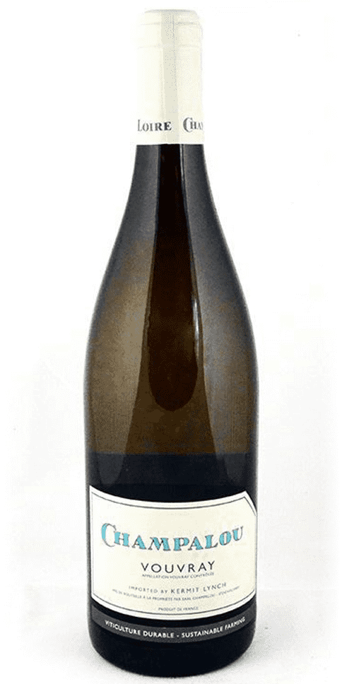

## Winery:

## Grape:

## Country:

## Regions:

## Vintage:

**Alcohol:**

Champalou

Chenin Blanc

France

Vouvray, Loire Valley

2018

12.50%

Retail Price: $ 24.00

[**Click Here to Reorder**](mailto:colin@flxhospitality.com?subject=Tasting%20Pack%20Reorder) **at F.L.X. Provisions**

In a world of uncertainty, we are:

In Our Element