

  

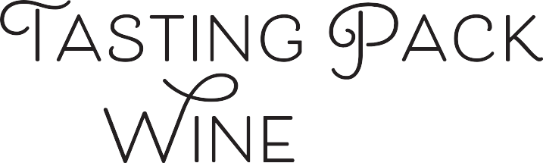

**#172**

# TASTING NOTES BY: MASTER SOMMELIER CHRISTOPHER BATES

Deep Opaque almost black core, with red coloration at the rim. Intense, deep black fruit aromas of cassis, jammy blackberries, and over ripe black plums are at the forefront of the nose. Minty, eucalyptus notes drive the nose, as does a slight roasted bell pepper note and clay like mineral. The palate stays ripe and sweet and is full and rich. The ripe fruit and continued ripeness on the palate are classic warm climate new world traits, and the eucalyptus note is a flag ship for Australia and a few other places around the world where the trees (and their pollen) fill the air around vineyards. While shiraz shows purple and black pepper notes, cab is often red with bell pepper.

# TASTING NOTES BY: F.L.X. TABLE’S MICHALIS KALAMPOUKAS

Dark ruby red, with high staining and tears forming slowly. On the nose is ripe, fruit forward with notes of ripe plum, blackberry and black currant. Slightly vegetal, driven by tobacco, bell pepper and eucalyptus notes, along with vanilla, spice and toast, indicating some oak aging. There's some minerality as well. Full bodied on the palate, the wine is dry, but ripe, rich and round, with elevated tannins, elevated acidity and high alcohol. Big and ripe, indicating new world. Slight oakiness with eucalyptus quality bringing us to a Australia instead of California

## Sweetness:

## Tannin:

## Alcohol:

## Acid:

Dry

Med Plus

High

Med Plus

old world   
or new?

climate?

grape?

country?

place



# WINE DETAILS:

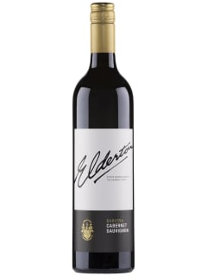

## Winery:

## Grape:

## Country:

## Regions:

## Vintage:

**Alcohol:**

Elderton

Cabernet Sauvignon

Australia

Barossa

2015

14.50 %

Retail Price: $ 24.00

[**Click Here to Reorder**](mailto:colin@flxhospitality.com?subject=Tasting%20Pack%20Reorder) **at F.L.X. Provisions**

In a world of uncertainty, we are:

In Our Element