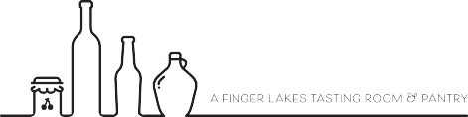

  

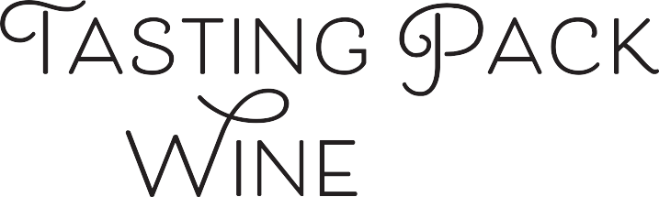

**#167**

# TASTING NOTES BY: MASTER SOMMELIER CHRISTOPHER BATES

Cloudy red core, with no browning. This wine smells like all forms of cherries first and foremost. Red and black, sweet and tart, and even bordering on cherry cola. There is a red floral note, some slight green herbal notes (like crushed green leaves), and a cola/licorice like spicy notes. Stays ripe on the palate.

# TASTING NOTES BY: ADVANCED SOMMELIER JOSHUA CARLSEN

This is a cloudy red wine, clean, with pale concentration of ruby with secondary colors of red and ruby, light rim variation, no signs of gas or sediment. Moderate plus tears. On the nose the wine is clean with moderate plus intensity of youthful aromas. Fruits are overripe and red: red cherry, red cranberry and red strawberry. Red flowers, rose. Rosemary and light green herbs. Black tea, cola, dried mushroom, pine forest floor, dry turned earth.. On the palate the fruits are the same and stay overripe.

## Sweetness:

## Tannin:

## Alcohol:

## Acid:

## Oak:

Dry

Moderate Minus

Medium

Medium

No evidence of new oak

old world   
or new?

climate?

grape?

country?

place?



# WINE DETAILS:

## Winery:

## Cuvee:

## Grape:

## Country:

## Regions:

## Vintage:

**Alcohol:**

**Elevage:**

Element

Pinot Noir

USA

Finger Lakes

2012

12-14%

24 Months in neutral oak

Retail Price: $61.00

[**Order**](mailto:colin@flxhospitality.com?subject=Tasting%20Pack%20Reorder) **at FLXProvisions.Com**

In a world of uncertainty, we are:

In Our Element